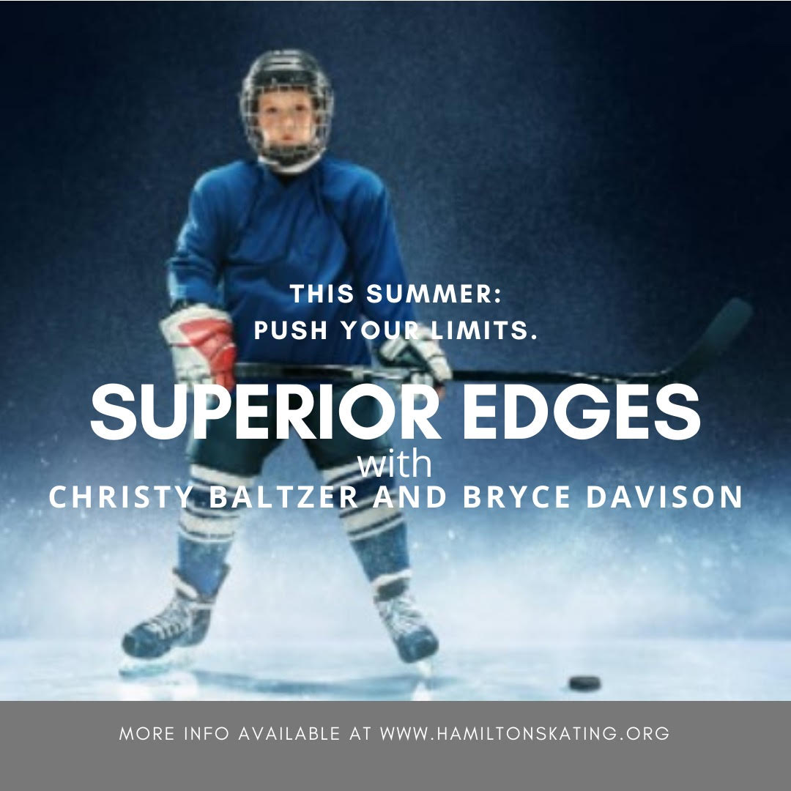


SUPERIOR EDGES
with CHRISTY BALTZER and BRYCE DAVISON

SUMMER 2022 July 4 - August 18, 2022
Please Print in BLOCK LETTERS
Last Name* |  |  |  |  |  | First Name*
Birth Date (YYYY/MM/DD)* |  | Gender *
Please state the Team or Program that you were registered in for the Winter 2022 season ___ ___________________________________________
Address*  City Postal Code |  |  |  |  | Name of (Primary) Parent / Guardian Information for skaters under 18 years old  Mother’s Name  Father’s Name
Home Phone # * (required) |  |  | Mobile Phone # |  | Emergency Contact (or Other Parent)
Email address* |  |  |  |  | Relationship to Skater |  |  |  | Contact Phone #

SUPERIOR EDGES | Level | 7 weeks
Wednesday 2:30pm - 3:30 pm | Intro; Chip; Tyke; & Novice House League | $315.00
Tuesday & Thursday 2:30pm - 3:30pm | ep Novice or Higher | $630.00
 |  | TOTAL

PLEASE NOTE: Applications must be completed in full. Payments can be made by: Debit, Cash or Cheques made Payable to “Hamilton Skating Club”
Etransfer to: billing.hamiltonskating@gmail.com Confirmations will not be sent out. No refunds.
No makeup sessions for personal holidays. NSF cheques are subject to a $40.00 administration fee and are to be replaced by certified cheque, money order, debit, cash or etransfer. Health & Safety Protocols must be followed at all times. Adhere to all signage in the facility
WAIVER: I HEREBY RELEASE THE HAMILTON SKATING CLUB (HSC), ITS DIRECTORS, OFFICERS AND COACHES FROM ANY AND ALL CLAIMS, ACTIONS, CAUSES OF ACTIONS, AND DAMAGES RESULTING FROM PERSONAL INJURY, THEFT, ACCIDENTS OR EXERCISE OR OTHER LOSS HOWEVER CAUSED.

Signature (or print) of Parent / Guardian/ Skater if 18+:

________________________ Date: ______________________

